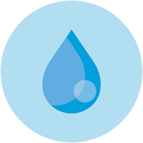**NYC Water Charges**

**NYCHA (Admin) Manual**

Table of Contents

* Log In 2
* View Buildings 3
* View Charges 5
* Delete Bill 6
* Edit Charge 8

Login (NYCHA Users)

Log In with the following credentials:

* Username: admin
* Password: nycha

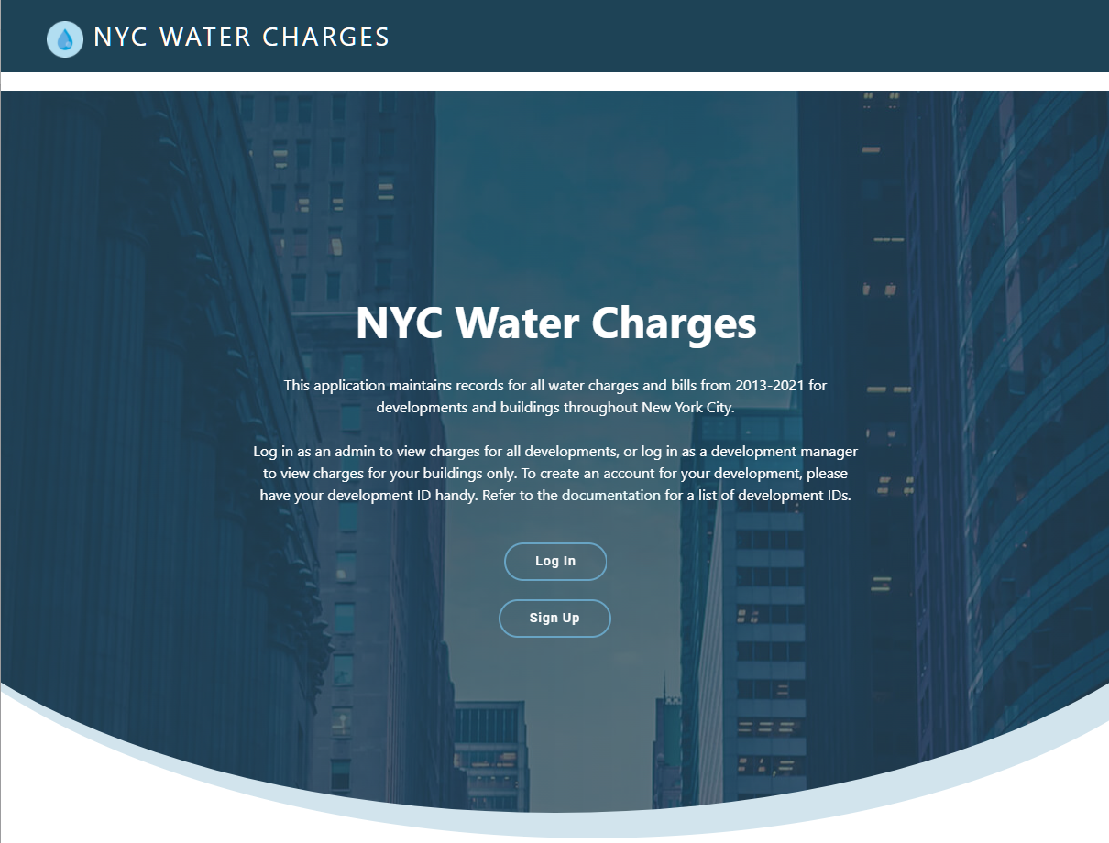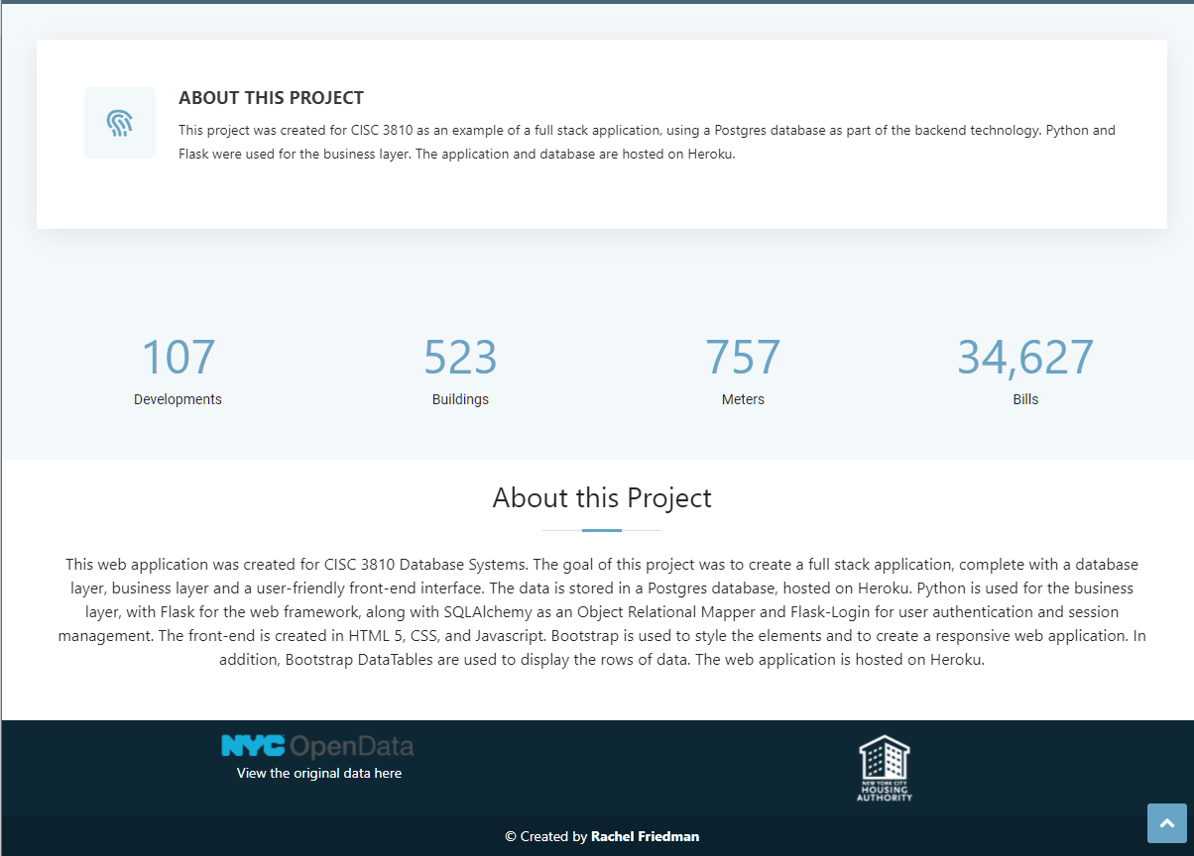

View Developments and Buildings (NYCHA Users)

1. Click on **Developments** (or Building) from the navigation bar.

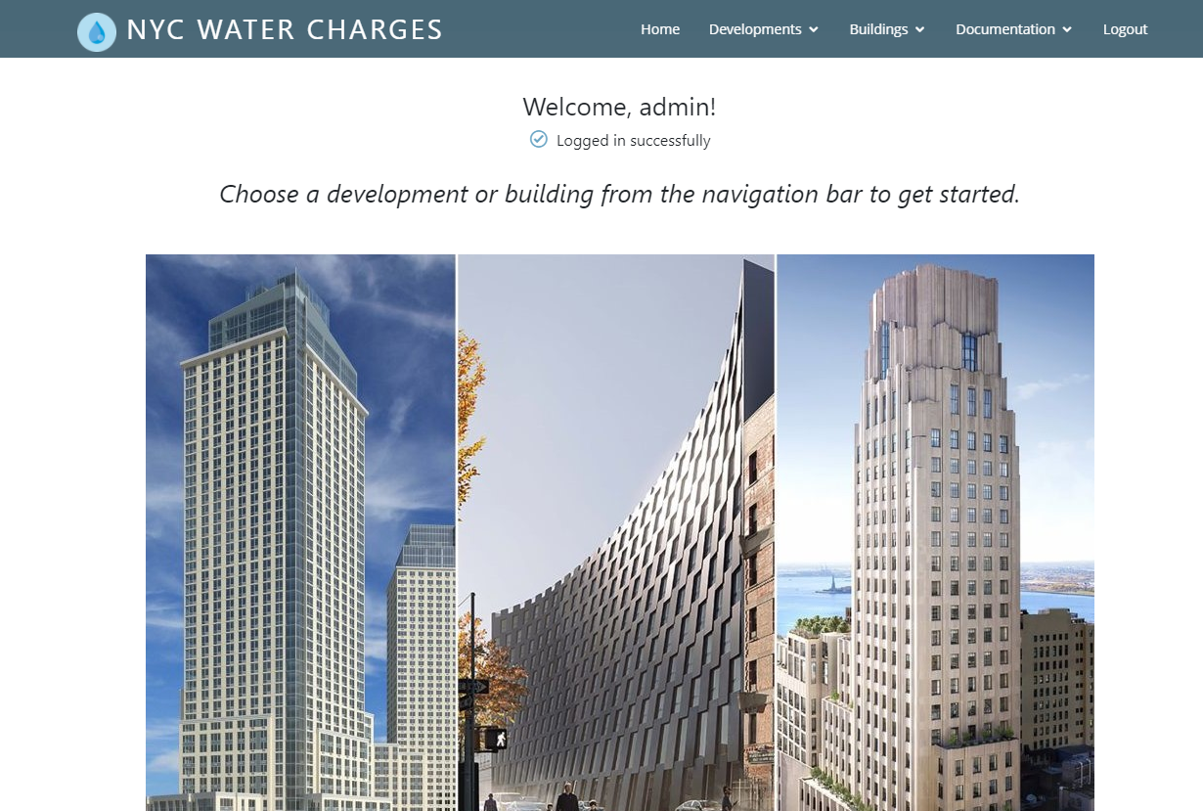

1. Choose a borough. (Due to space constraints, only **Brooklyn** data is available at this point.)

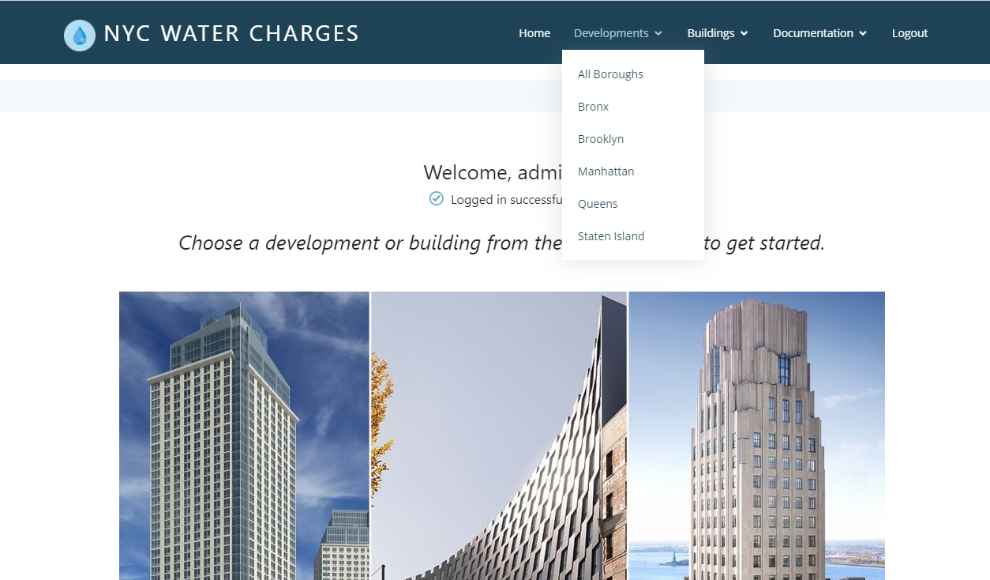

1. You will be presented with a list of all developments in that borough.

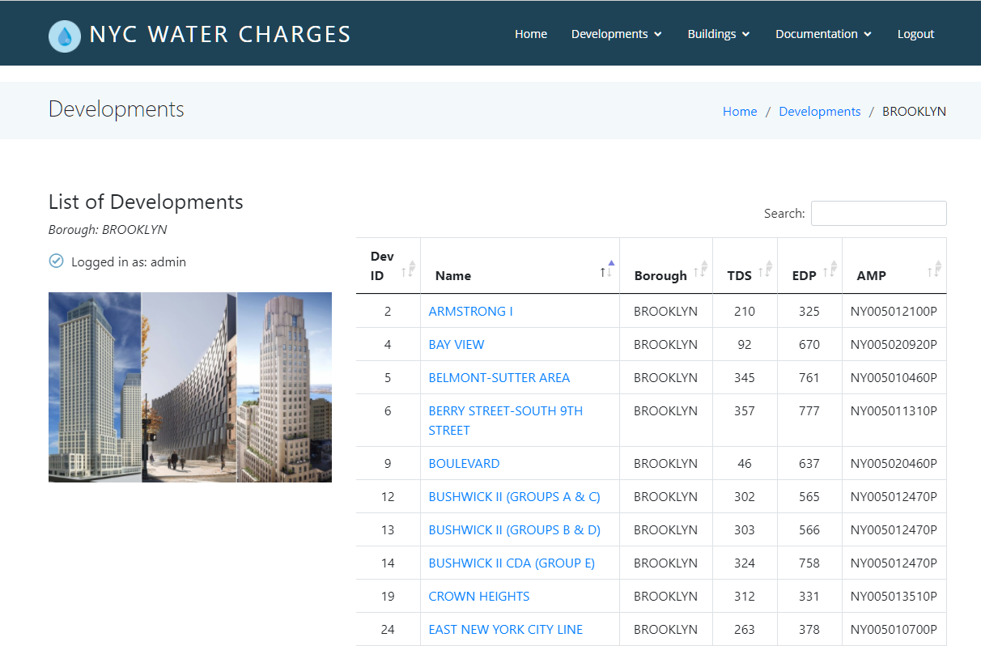

1. Click on a development to see a list of buildings owned by that development.

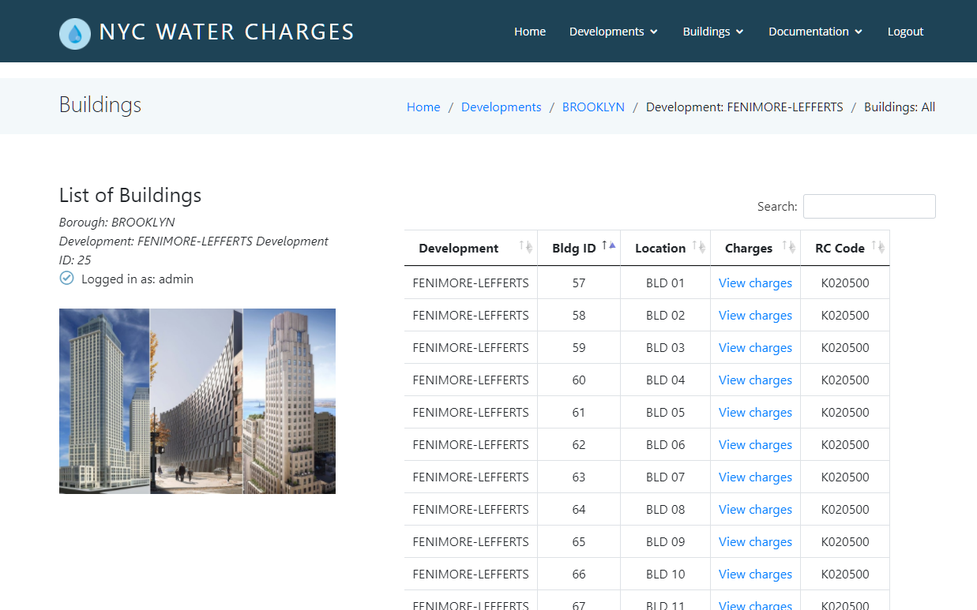

View Charges (NYCHA User)

1. When viewing a list of buildings, click on **View charges** to view charges associated with that building.



1. As a NYCHA/admin user, you are able to **delete** a bill, or **edit** a charge.

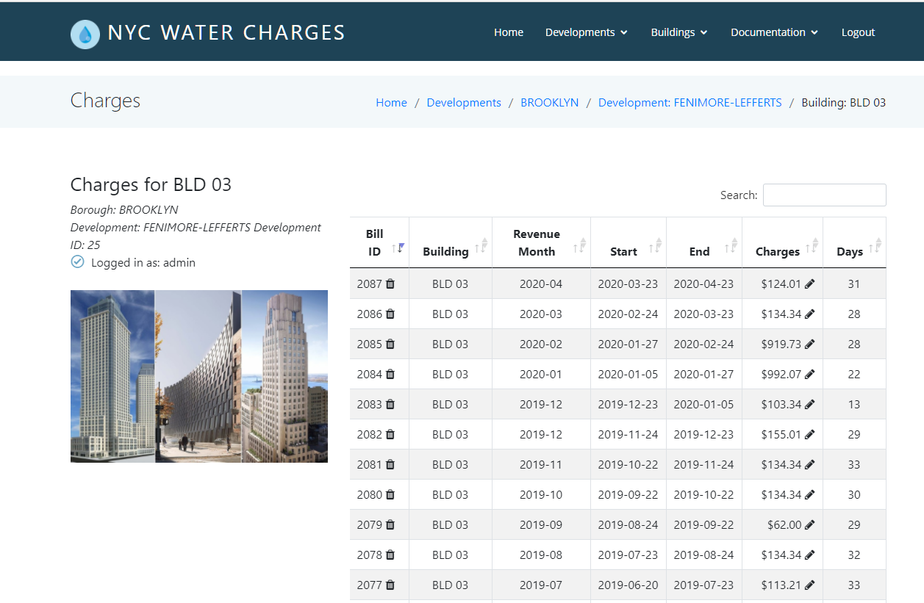

Delete a Bill (NYCHA User)

1. After viewing the list of charges, click on the **Delete** symbol next to the Bill ID.

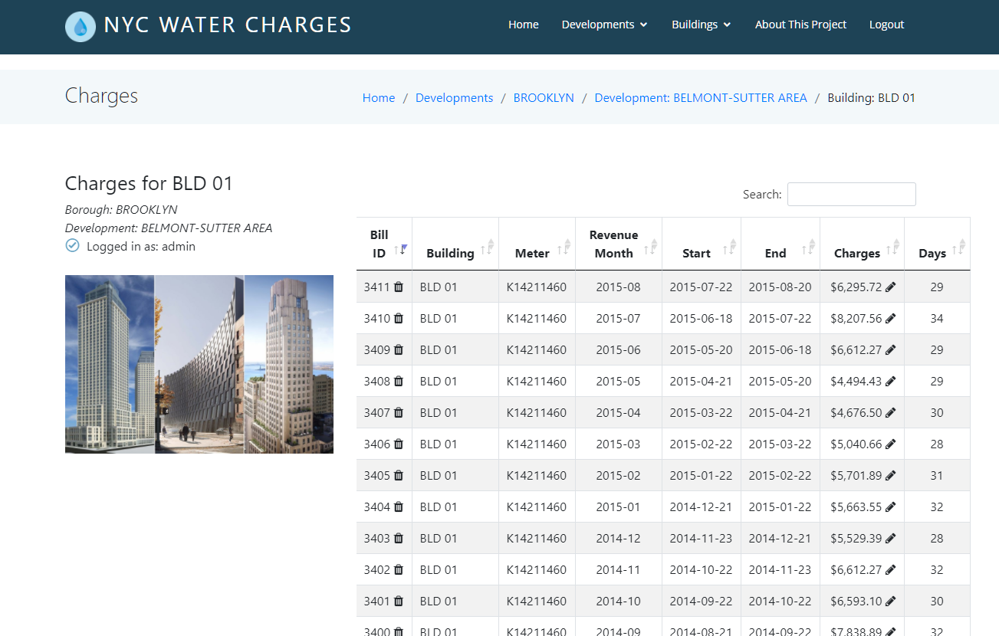

1. Press OK to confirm that you wish to delete, or Cancel if you wish to cancel.

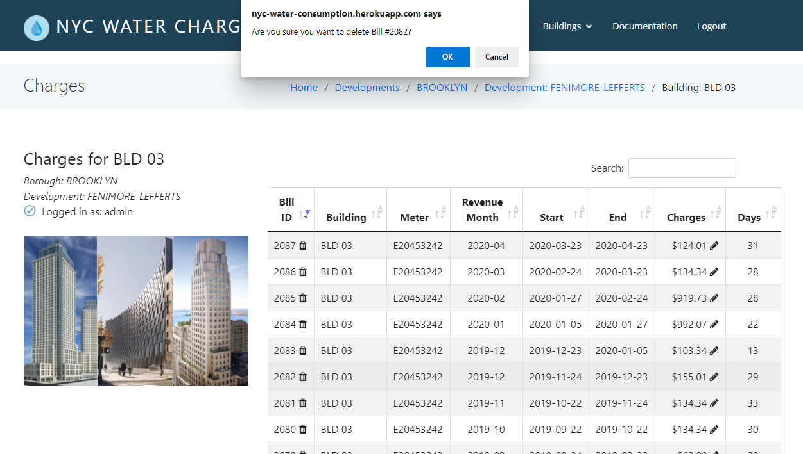

1. An alert will appear on your screen, informing you that the bill was deleted. That bill will no longer appear in the list of charges.

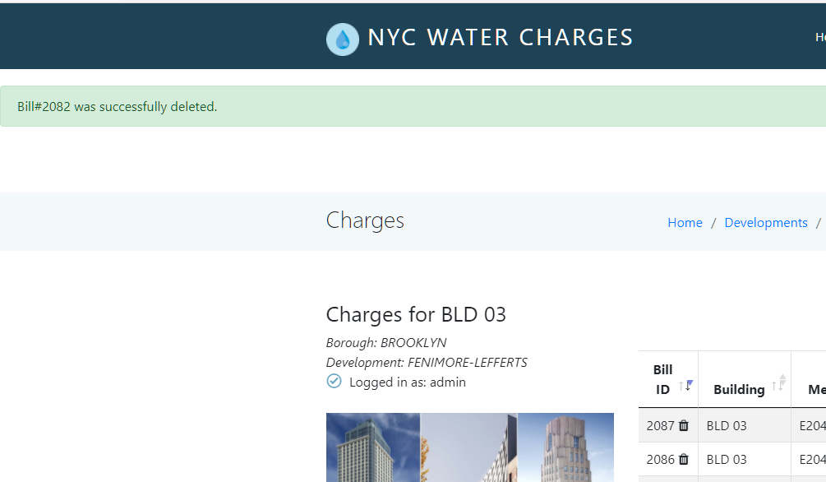

Edit a Charge (NYCHA User)

1. Click on the Edit symbol next to the charge to edit the charge.



1. Enter the amount of the new charge.

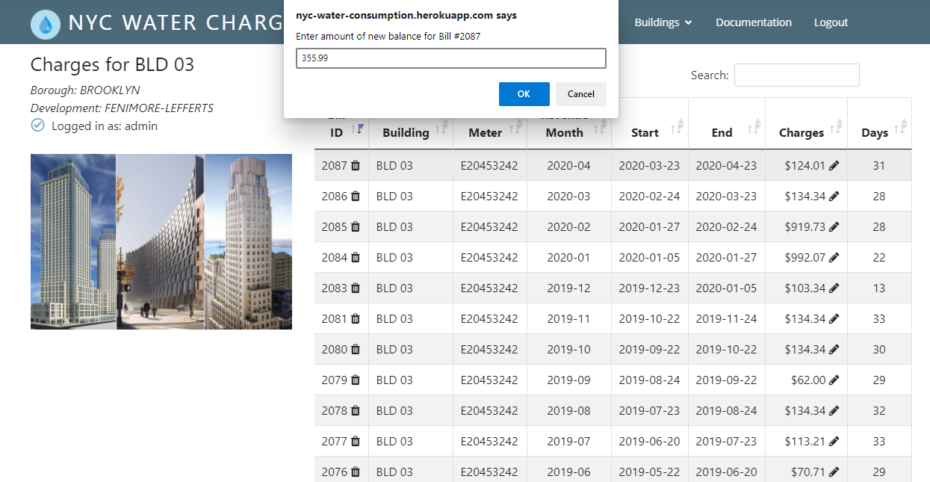

1. Press OK to confirm, or cancel to undo the change.

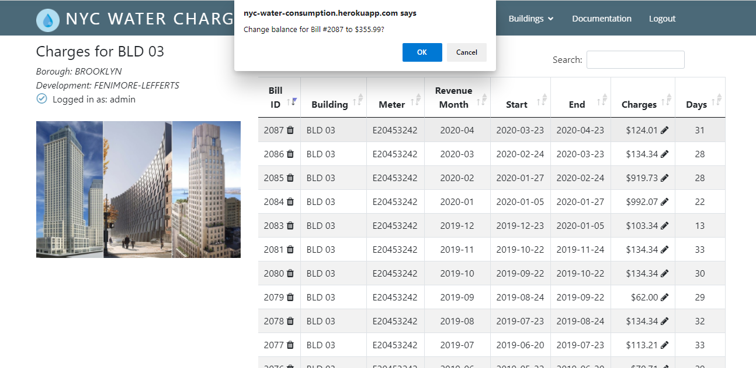

1. After pressing OK an alert will appear, confirming that the amount was updated.

